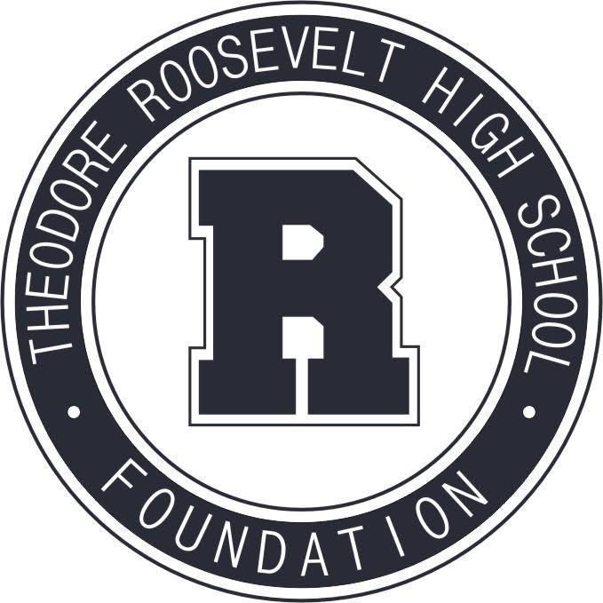

TRHS Foundation Meeting
October 11, 2021

The Roosevelt Foundation works to celebrate Roosevelt’s history and traditions,
and to support Roosevelt students and faculty in their pursuit of excellence.

- Welcome & Call to Order
- Approval of September Meeting Minutes
- Committee Reports
  - Communications & Marketing
  - Education + Engagement
  - Alumni Events & Relations
  - Capital Campaign
  - Community Events & Fundraising
- R Party Discussion
- Treasurer's Report
6. Open for questions & concerns

NEXT MEETING: Monday, November 8 at 5:30 p.m.

