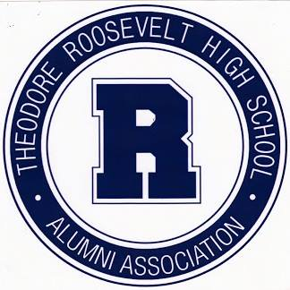
EDUCATION
KATHY COLLINS REILLY SCHOLARSHIP
Kathy Lee Collins graduated from Roosevelt High School in 1968 with a B+ average. She was very active at Roosevelt as a cheerleader and Pep Club Chair. She went on the University of Kansas where she received her degree in Education. After teaching for several years, she earned her law degree from Drake University and worked as an attorney for the Iowa Department of Education. She has established a scholarship to help students who plan to become teachers. To be eligible for the scholarship, a Roosevelt senior (or junior graduating early) must have a minimum of 2.5 grade point average. Amount of award: $1,000.00 per year for a maximum of five years.
WRITE AN ESSAY
Save and email essay to trhsfoundationdm@gmail.com with the name of the scholarship for which you are applying in the email subject line (one scholarship per email):
1)Write an original essay (500-1000 words) on the value of humor as a teaching tool in the classroom.
REQUIRED REFERENCES
Send references listed below to trhsfoundationdm@gmail.com with the name of the scholarship for which you are applying in the email subject line (one scholarship per email):
– Roosevelt teacher or administrator, focusing on what kind of teacher the student could or will be, in addition to describing the student’s strengths and weaknesses.
​

