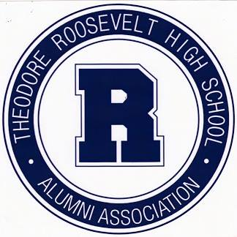
PRE-MED
TIMOTHY PARKER, M.D. PRE-MEDICINE SCHOLARSHIP
Dr. Timothy Parker graduated from Roosevelt High School in the Class of 1981. He later became a physician and practices medicine in Leawood, Kansas. He is pleased to offer a scholarship to a deserving Roosevelt senior who has a goal and a passion to become a nurse or a doctor. The applicant must have good performance in math and science and a financial need. Amount of award: $1,000.
WRITE AN ESSAY
Save and email to trhsfoundationdm@gmail.com with the name of the scholarship for which you are applying in the email subject line (one scholarship per email):
1) Describe your motivation and passion to become a nurse or a medical doctor.
REQUIRED REFERENCES
Send references listed below to trhsfoundationdm@gmail.com with the name of the scholarship for which you are applying in the email subject line (one scholarship per email):
-Roosevelt science teacher (biology, chemistry, or physics).
-Character reference by a friend, member of the clergy, or employer.

