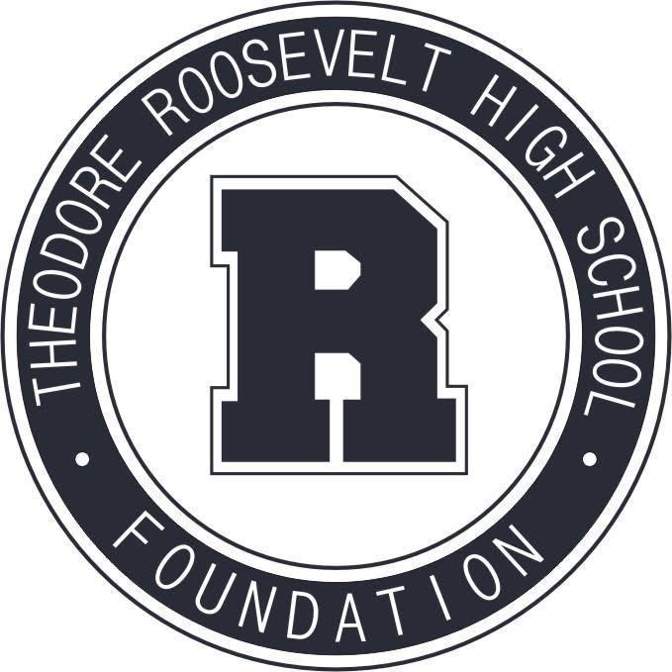

TRHS Foundation Meeting
March 8, 2021

The Roosevelt Foundation works to celebrate Roosevelt’s history and traditions,
and to support Roosevelt current students and faculty.

- Welcome & Call to Order

- Introduction of Neumann Monson Architects
Channing Swanson, AIA, Principal
Cheung Chan, AIA, Project Manager

- Approval of February Meeting Minutes

- Treasurer's Report

- Principal’s Report

- Committee Reports
Alumni Relations + Events
- Rider Cup Sponsor Brainstorm
Communications + Marketing
Scholarships + Grants Committee
Capital Campaign Committee
- Library Revisioned Design Services Contract: Neumann Monson
Other
- Development Plan
Review Calendar: Committee Activities through Summer 2021

- Thank Yous

