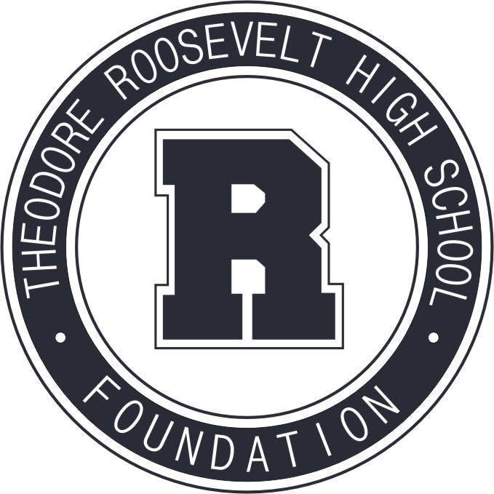

TRHS Foundation Meeting
February 8, 2021

The Roosevelt Foundation works to celebrate Roosevelt’s history and traditions,
and to support Roosevelt current students and faculty.

- Welcome & Call to Order

- Approval of January Meeting Minutes

- Principal’s Report

- Treasurer's Report

- Special Requests
Senior Party
Mock Trial

- Administrative Report

- Committee Reports
Scholarships + Grants Committee
Alumni Relations + Events
- 2021 Hall of Fame
- Reunion Tours Discussion
Capital Campaign Committee
Review Calendar: Committee Activities through Summer 2021

- Thank You Notes

Upcoming Dates:
- Monthly Newsletter: Friday, February ?, 2021
- Next Board Meeting: Monday, March 8, 2021

