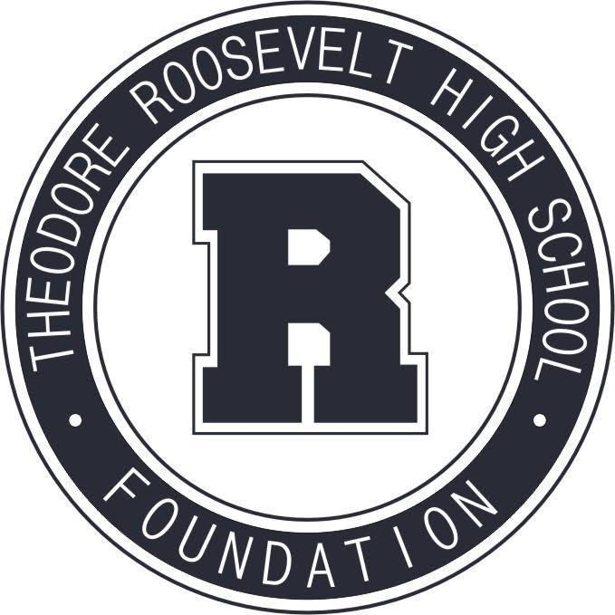

TRHS Foundation Meeting
August 9, 2021

The Roosevelt Foundation works to celebrate Roosevelt’s history and traditions,
and to support Roosevelt students and faculty in their pursuit of excellence.

- Welcome & Call to Order
- Special Guest: Shreeya Yarlagadda, 2021 Business Horizons Scholarship recipient
- Approval of July Meeting Minutes
- Treasurer's Report
- President’s Report
- Staffing committee
- Recognition of departing board members
- Committee Check-In
- Revisit committee assignments and roles
- Work Calendar
- Budget for 2021-22 year

Community Events + Fundraising
- R Party idea
Alumni Relations + Events
- Reunion support
- Help with capital campaign “Class Gifts”initiative
Communications + Marketing
- Rider Pride social media campaign
- Alumni or student highlight in newsletter
Education + Engagement (formerly Scholarships + Grants Committee)
- Educate staff on grant availability
- Scholarship Donor follow-ups
- Propose changes for next year
- Documentation of scholarship program+recipients
- Finalize+promote Schiffler Fund
Capital Campaign
- General update on timeline, projects+fundraising

